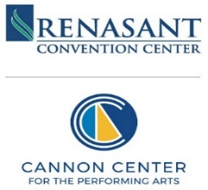

NOTICE OF
MEMPHIS CONVENTION CENTER COMMISSION - REGULAR MEETING
Wednesday, October 29, 2025 – 3:00 PM Central Standard Time
Meeting Location: LL – RM: Lower-Level 1

This Notice of Meeting provides instructions on how public members can submit written comments regarding any agenda item or other matter to be considered before the meeting.

A G E N D A

- Opening Remarks and Approval of the Commission Chairman, Calvin Anderson
  - Meeting Minutes (September)

- Financial Review Commissioner Lee Jackson
  - Monthly Financial Reports August 2025* Chuck Jabbour

III. RCC Directors’ Reports
  - Dashboard / Closed Sales Camille Wellington
  - RCC Calendar & Customer Survey Report LeeAnn Shewbart
  - Cannon Center Events & Calendar Trey Giuntini
  - Operations Update Marvin Lopez
  - Marketing/In-House Events Savanna Gifford
  - Public Safety Update Constance Ficklen

IV. General Manager/MMG Report Dean Dennis

V. Public Comments Individuals who wish to submit a public comment related to an agenda item, please get in touch with Ella Young at eyoung@memphisrcc.com

VI. Comments & Adjournment Chairman Calvin Anderson

VII. Executive Session TBD

