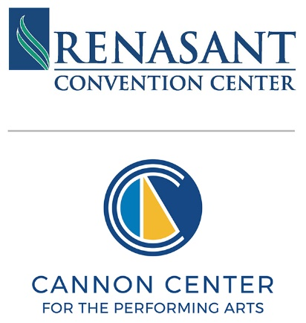

NOTICE OF
MEMPHIS CONVENTION CENTER COMMISSION - FINANCE COMMITTEE MEETING
Wednesday, October 29, 2025– 2:30 PM Central Standard Time
255 North Main Street, Memphis, TN 38103
Meeting Location: LL – RM: Lower-Level 1

This Notice of Meeting contains instructions on how public members may provide written comments concerning any agenda item or other matter before the meeting.

A G E N D A

- Opening Remarks and Approval of the Commission Chairman Lee Jackson
Meeting Minutes (July)*

- Financial Reports
  - Monthly Financial Reports August 2025* Chuck Jabbour

- Adjournment Chairman Lee Jackson

*Denotes voting item

If you have any questions or comments regarding this agenda or meeting, please email info@memphisrcc.com. We encourage you to share your thoughts and queries.

